[](https://www.google.co.uk/imgres?imgurl=https://www.whatdotheyknow.com/request/408175/response/983275/attach/3/image001.png?cookie_passthrough=1&imgrefurl=https://www.whatdotheyknow.com/request/it_infrastructure_224&docid=xTXl5iHDh7WHpM&tbnid=Z2A1fhE-3YafpM:&vet=10ahUKEwiDzqiX4tzYAhUUM8AKHQuDDq8QMwg9KAAwAA..i&w=124&h=124&itg=1&safe=strict&bih=676&biw=1360&q=wrexham%20council%20logos&ved=0ahUKEwiDzqiX4tzYAhUUM8AKHQuDDq8QMwg9KAAwAA&iact=mrc&uact=8)[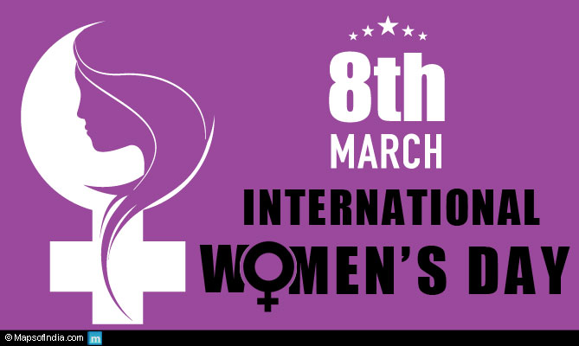](https://www.google.co.uk/url?sa=i&rct=j&q=&esrc=s&source=images&cd=&cad=rja&uact=8&ved=0ahUKEwiI5are1tzYAhUEcRQKHT9eB9sQjRwIBw&url=https://www.mapsofindia.com/my-india/society/international-womens-day-what-does-this-mean-to-us/attachment/international-womens-day&psig=AOvVaw12ACyzjWyk0fBuG3yX-dJ0&ust=1516198438598462)

Wrexham’s Youth Service Participation Team is supporting International Women’s Day 2018

International **Women's Day** is annually held on **March** 8 to **celebrate women's** achievements throughout history and across nations. It is also known as the United Nations (UN) **Day** for **Women's** Rights and International Peace.  **International Women's Day** ​ is a global day celebrating the social, economic, cultural and political achievements of women and this year - 2018 celebrates 107 years of celebrations with thanks to the suffragettes.

**International Women's Day is all about unity, celebration, reflection, advocacy and actions.**

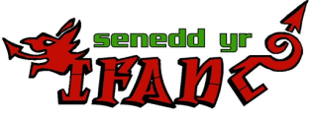[](http://www.google.co.uk/url?sa=i&rct=j&q=&esrc=s&source=images&cd=&cad=rja&uact=8&ved=0ahUKEwjOl8Pg49zYAhVFWRQKHcpnBzQQjRwIBw&url=http://www.thebeijinger.com/blog/2016/03/04/celebrate-international-womens-day-these-x-events-march-8&psig=AOvVaw16y7zs2cl_EOtGowFBfh4r&ust=1516202264270883)

"The story of women's struggle for equality belongs to no single feminist nor to any one organization but to the collective efforts of all who care about human rights." So make International Women's Day your day and do what you can to truly make a positive difference for women ***Gloria Steinem***

Calling young women

**Do you have an interest in high power Career??**

**To support International Women’s Day 2018, Wrexham’s Participation Team would like to give some young women aged between 11 – 20, from Wrexham, the opportunity to ‘shadow’ some of our inspirational women in various jobs and settings for the day. This is a fantastic opportunity with the aim that it will inspire and encourage young women to consider many occupations.**

**Would you like this opportunity?????**

**If you’re interested or would like further information please contact the Participation Team**

**01978 317961**

[**youngvoices@wrexham.gov.uk**](mailto:youngvoices@wrexham.gov.uk)

[**www.internationalwomensday.com**](https://www.internationalwomensday.com/) **#IWD2018** [**#PressforProgress**](https://www.internationalwomensday.com/Theme)

Wrexham Participation Team supports the Senedd yr Ifanc (Youth Parliament) and youth voice in Wrexham.