Brymbo Youth Workers
will be available
Monday/Thursday
6 pm – 8 pm
at the Skate park Cheshire View
Come and see us and tell us what you want
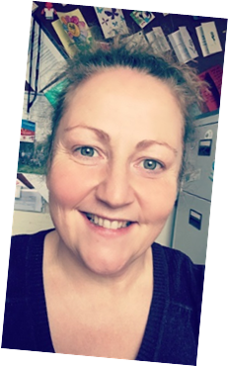
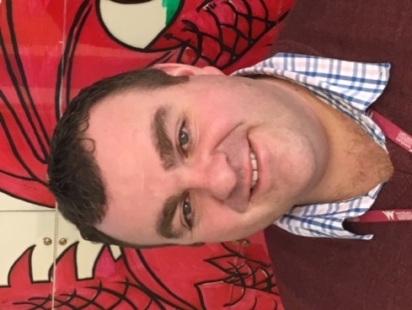
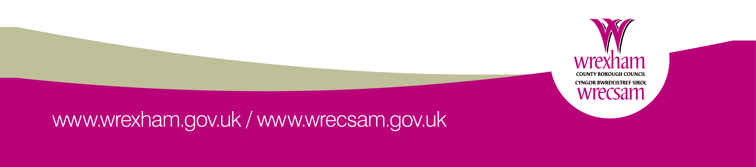
Julie Davies
Richard Thomas

