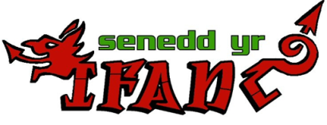
Community Organising training for young people aged 11 -21

Together Creating Communities ( TCC) and Senedd Yr Ifanc ( Wrexham Young People’s Parliament)are holding Community Organising training for young people aged 11 -21
On this training course interactive workshops will challenge you to develop leadership skills and become more active in your community and public life.
During the training you will : . . .
- Develop the skills and confidence to take action in your community
- Learn how you can plan and run strategic campaigns
- Build relationships with others from diverse groups and communities
Date – 12th May 2018
Times – 9.15 am until 4pm
Wrexham Venue (TBC)
LUNCH WILL BE PROVIDED BY WREXHAM PARTICIPATION TEAM

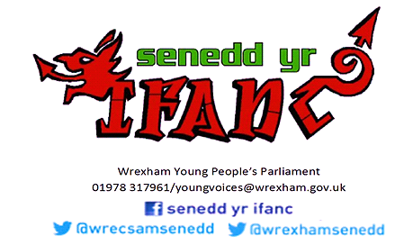
This training is free if you live in or have contacts with Wrexham, If you’re interested in being a part of this training or want more information contact us on 01978 317 961 or email youngvoices@wrexham.gov.uk

