[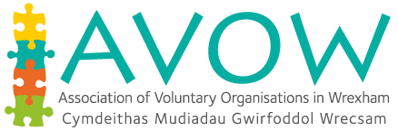](http://www.avow.org/)Wrexham County Borough Council - Cyngor Bwrdeistref Sirol Wrecsam

Does your organisation need funding for a youth work project that will make a difference to the community and support young people?

Organisations working with young people aged 11-25 can now apply for £200 to £500 from the Youth Service Strategy Revenue Grant 2018/2019.

**What could you do with**

**£200 – £500?**





For more information please contact:

Tricia Jones – [ctricia.jones@wrexham.gov.uk](mailto:ctricia.jones@wrexham.gov.uk) 01978 317961

Caroline Bennett – [caroline.bennett@wrexham.gov.uk](mailto:caroline.bennett@wrexham.gov.uk) 01978 317961

The panel will be meeting to consider application on set dates throughout the year*, if you would like to have your application considered please return complete forms by:

**1st Closing date - Friday 29th June**

**2nd Closing date - Friday 28th September**

**3rd Closing date - Friday 23rd November**

*Please allow 3 weeks from the closing date for notification of outcome and money to be processed