Thank you for taking time to help facilitate this discussion. The Interim Youth Work Board for Wales want the views of young people to be central to the work it does. It is important that both they and you as workers, feel engaged in the process. In order to be able to collate the information provided we would like you to summarise your conversation below (this is where your skills as a practitioner will be needed as we are asking you to translate the language the young people have used into the categories provided. Where an ‘other’ option is provided; space has been given to offer more details)
Group size:

Age Range:

Organisation:
Q1: What does youth work mean to you? (Here we would like you to categorise what young people said – the boxes are for how many people identified that particular category – the responses may cover multiple categories)

Socialising Advice & Guidance Safe place

Try new things Support Help into work/education

Qualifications Information Other

Q2: What does youth work offer you now?

Socialising Advice & Guidance Safe place

Try new things Support Help into work/education

Qualifications Information Other
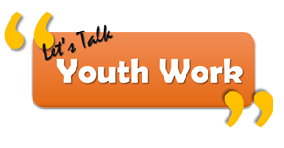
Q3: What would you like youth work to offer? (We understand that summarising these answer can prove difficult but would like you to reflect on any emerging themes)
More emphasis on:

Less emphasis on:

Q4: How do you want to be involved in shaping youth work?
Social media
If young people chose social media, what platforms and why?

Events/workshops
Any ideas for workshops or events?

Youth workers
Any additional comments welcomed:
How could youth workers best be utilised to help?

