

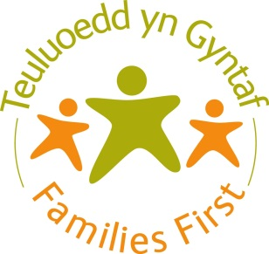

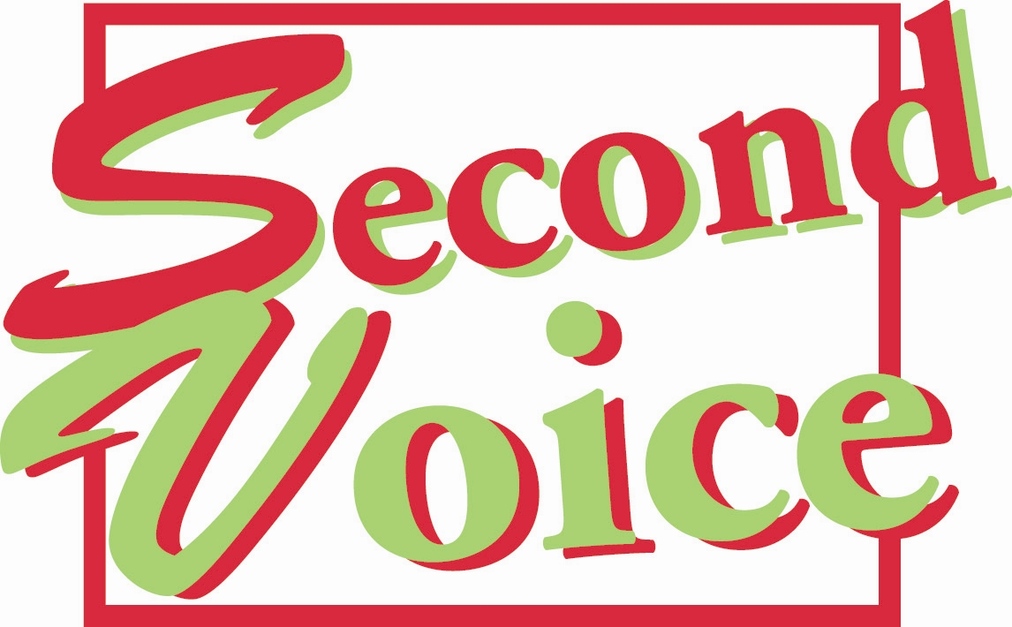

*Gwasanaeth Eiriolaeth Pobl Ifanc*

*Advocacy Service for Young People*

**Tel/Ffôn: 0800 0322 630**

**Atgyfeiriad at y GWASANAETH EIRIOLAETH AIL LAIS**

**ar gyfer Pobl Ifanc 11-25 oed**

**Referral for SECOND VOICE ADVOCACY SERVICE**

**for Young People aged 11 – 25**

|  |  |
| --- | --- |
| Enw Cyntaf: Cyfenw:  Forename: Surname: | At ddefnydd y swyddfa’n unig / For office use only  Dyddiad derbyn yr atgyfeiriad:  Date referral received:  Rhif yr Achos: Rhif Capita:  Ref Case number: Capita no:  Eiriolwr:  Advocate:  Ail –atgyfeiriad? Ydi/ Nac ydi  Re-referral? Yes / No |
| Cyfeiriad yr unigolyn ifanc:  Young person’s address: |
| Cod Post:  Post Code: | Oedran:  Age: |
| Dyddiad geni:  Date of birth: | Rhyw:  Gender : |
| Rhif cyswllt yr unigolyn ifanc:  Contact number young person: | A oes gan yr unigolyn ifanc weithiwr cymdeithasol? Does the young person have a social worker open?  Oes / Yes  Nac Oes / No  Os **oes**, y gwasanaeth sy’n rhaid i chi gysylltu ag ef yw TGP Cymru 0800 111 6880  If **yes** the service you need to contact is TGP Cymru  0800 111 6880 |
| Beth yw’r ffordd orau o gysylltu â’r unigolyn ifanc?  What is the best way to contact the young person? | E—bost / Email  Llythyr / Letter  Ffôn / Telephone  TESTUN / TEXT  Ffôn Symudol / Mobile |
| Rhif cyswllt rhiant / gofalwr:  Contact number parent/carer: | Enw’r sawl sy’n atgyfeirio:  Name of referrer: |
| Enw’r Meddyg Teulu :  G.P’s name: | Dynodiad / perthynas y sawl sy’n atgyfeirio:  Designation / relationship of referrer: |
| Cyfeiriad y Meddyg Teulu:  G.P’s address: | Cyfeiriad y sawl sy’n atgyfeirio:  Referrer address: |
| Ysgol  School: | Rhif cyswllt y sawl sy’n atgyfeirio:  Contact number of referrer: |
| A yw’r unigolyn ifanc wedi cytuno i’r atgyfeiriad?  Do  Naddo  Os nad yw wedi cytuno, pam? Ni allwn dderbyn yr atgyfeiriad.  Has the young person agreed to the referral? Yes  No  If not why? We cannot accept referral | A yw’r rhieni / gofalwyr yn ymwybodol o’r atgyfeiriad?  Ydynt  Nac ydynt  Amherthnasol  Os nac ydynt, pam?  Is the parent/guardian aware of the referral?  Yes  No  N/A  If not why? |
| Iaith gyntaf yr unigolyn ifanc:  Young person’s first language: | **Do you need a translator / Welsh speaker?**  **A oes angen cyfieithydd/ siaradwr Cymraeg arnoch?**  **Yes / Oes**  **No / Nac oes** |
| Mewn:  In : | Addysg / Education  Cyflogaeth / Employment  Hyfforddiant / Training  Nid mewn Cyflogaeth, Addysg neu Hyfforddiant / NEET  Rhiant / Parent |
| Nodwch y rheswm dros atgyfeirio:  Please state reason for the referral: | |
| **A oes gan yr unigolyn ifanc unrhyw risg hysbys a allai effeithio ar y ffordd y mae’n gweithio gyda ni? (risg i’w hunan neu eraill)** e.e. ymddygiad ymosodol neu gam-drin geiriol.  **A oes gan yr unigolyn ifanc unrhyw gyflyrau meddygol / iechyd (yn cynnwys iechyd meddwl) y dylem fod yn ymwybodol ohonynt?** e.e. hunan-niweidio, meddwl am hunan-laddiad, meddyginiaeth reolaidd  **Does the young person have any known risks which may affect the way they work with us? (risks to self or others)**  Eg. Aggression or verbal abuse  **Does the young person have any medical/health (incl. mental health) issues which we should be aware of?**  Eg. Self-harm, suicidal thoughts, regular medication   |  |  |  | | --- | --- | --- | | **Math o risg sy’n bresennol (nid yw’r rhestr yn un gyflawn)** / **Type of risk present (not exhaustive):** | **Oes / Yes** | **Nac Oes / No** | | ***Risg i’r hunan:*** meddwl am hunan-laddiad, hunan-niweidio, ceisio hunan-laddiad, cam-drin sylweddau, natur fyrbwyll, hunan-esgeuluso, ymddygiad mentrus  ***Risk to self:*** suicidal thoughts, self-harm, suicide attempts, substance misuse, impulsivity, self-neglect, risky behaviour |  |  | | ***Risg i eraill:*** ymddygiad ymosodol / treisgar / rhywiol amhriodol / byrbwyll, hanes o honiadau ffug, heintiau, materion yn ymwneud â chludo  ***Risk to others:*** aggressive / violent / sexually inappropriate / impulsive behaviour, history of false allegations, infection, issues re transporting, |  |  | | ***Risg gan eraill:*** *cam-drin domestig. trais yn seiliedig ar anrhydedd, camfanteisio troseddol / rhywiol, diffyg goruchwyliaeth / pryder rhieni*  ***Risk from others:*** domestic abuse, honour based violence, sexual/ criminal exploitation, parental lack of concern/ supervision, |  |  |   **Os ydych wedi rhoi tic mewn un blwch neu fwy, bydd rhaid i chi ofyn am ffurflen asesiad risg unigol i’w chwblhau.**  **If one or more box ticked you will need to request an individual risk assesment form to complete .** | |
| A oes gan yr unigolyn ifanc anabledd (h.y. Anghenion cyfathrebu, ASD, anawsterau llythrennedd)?  Oes  Nac oes  Os oes, manylion pellach:  Does the young person have a disability (ie. Communication needs, ASD, literacy difficulties)?  Yes  No  If yes, further details: | |
| Crefydd / Materion Diwylliannol Eraill - Religion/other cultural issues:   |  |  |  |  |  |  |  | | --- | --- | --- | --- | --- | --- | --- | | Prydeinig (Gwyn) / British (White) |  | Gwyn a Du Affricanaidd (Cymysg) / White & Black African (Mixed) |  | Bangladesiaidd / Bangladeshi |  | Unrhyw Grŵp Ethnig Arall / Any Other Ethnic Group | | Gwyddelig (Gwyn) / Irish (White) |  | Gwyn ac Asiaidd (Cymysg) / White & Asian (Mixed) |  | Caribïaidd (Du neu Ddu Prydeinig) / Caribbean (Black or Black British) |  | | Cymreig / Welsh |  | Unrhyw Gefndir Cymysg Arall / Any Other Mixed Background |  | Affricanaidd (Du neu Ddu Prydeinig) / African (Black or Black British) |  | | Unrhyw Gefndir Gwyn Arall / Any Other White Background |  | Indiaidd (Asiaidd neu Asiaidd Prydeinig) / Indian (Asian or Asian British) |  | Unrhyw Gefndir Du Arall / Any Other Black Background |  | | Gwyn a Du Caribïaidd (Cymysg) / White & Black Caribbean (Mixed) |  | Pacistanaidd (Asiaidd neu Asiaidd Prydeinig) / Pakistani(Asian or Asian British) |  | Tsieineaidd (Grŵp Ethnig Arall) / Chinese (Other Ethnic Groups) |  | Heb Nodi / Not Stated | | |
| Llofnod yr Atgyfeirydd / Referrer signature Dyddiad / Date:  **Am wybodaeth ynglŷn â sut mae Cyngor Bwrdeistref Sirol Wrecsam yn defnyddio data personol, gweler ein Hysbysiad Preifatrwydd ar ein gwefan:** [**www.wrecsam.gov.uk**](http://www.wrecsam.gov.uk)  **For information as to how Wrexham County Borough Council handles personal data, please see our Privacy Notices on our website:** [**www.wrexham.gov.uk**](http://www.wrexham.gov.uk)  Anfonwch y ffurflenni atgyfeirio wedi’u cwblhau a’u nodi â **‘Preifat a Chyfrinachol’** at /Please send completed referral forms marked ‘**Private and Confidential’** to:  **Dychwelwch at:** Second Voice, Stryt Lambpint, Wrecsam LL11 1AR Ffôn: 01978 295600 Rhadffon: 0800 0322 630, Ffacs: 01978 265608 E-bost: [secondvoice@wrexham.gov.uk](mailto:secondvoice@wrexham.gov.uk)  **Return to:** Second Voice, Lambpit Street Wrexham LL11 1AR Tel: 01978 295600 Free phone: 0800 0322 630, Fax: 01978 265608 Email: [secondvoice@wrexham.gov.uk](mailto:secondvoice@wrexham.gov.uk) | |